SQL INSERT INTO

🌟 Definition
# Source: AI Source: Provided by: [Data Path: Persons Table -> ID Column: 1, Name_En Column: Motasem Essam] -> From: [ChatGPT] on [6/11/2026]
SQL INSERT INTO is a statement used to add new records (rows) into a table.
Whenever you want to store new data in a database, you use INSERT INTO.

🎯 Purpose
# Source: AI Source: Provided by: [Data Path: Persons Table -> ID Column: 1, Name_En Column: Motasem Essam] -> From: [ChatGPT] on [6/11/2026]
INSERT INTO is used to:
- Add new customers
- Add new products
- Add new orders
- Add employee records
- Store any new data in a table

🧠 Simple Example
# Source: AI Source: Provided by: [Data Path: Persons Table -> ID Column: 1, Name_En Column: Motasem Essam] -> From: [ChatGPT] on [6/11/2026]
Customers Table
CustomerID | Name | City
1 | Ali | Cairo

SQL Statement
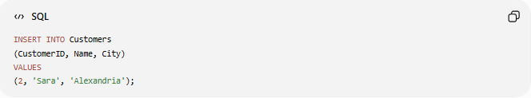
INSERT INTO Customers
(CustomerID, Name, City)
VALUES
(2, 'Sara', 'Alexandria');

Result
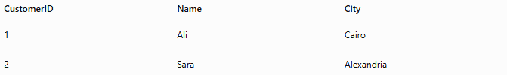
CustomerID | Name | City
1 | Ali | Cairo
2 | Sara | Alexandria
A new row has been added.

📝 Syntax
# Source: AI Source: Provided by: [Data Path: Persons Table -> ID Column: 1, Name_En Column: Motasem Essam] -> From: [ChatGPT] on [6/11/2026]
Insert Specific Columns
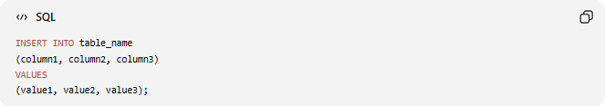
INSERT INTO table_name
(column1, column2, column3)
VALUES
(value1, value2, value3);

Example
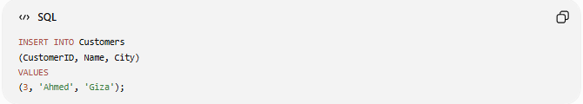
INSERT INTO Customers
(CustomerID, Name, City)
VALUES
(3, 'Ahmed', 'Giza');

📚 Insert All Columns
# Source: AI Source: Provided by: [Data Path: Persons Table -> ID Column: 1, Name_En Column: Motasem Essam] -> From: [ChatGPT] on [6/11/2026]
If values are provided for every column, column names may be omitted.
Syntax
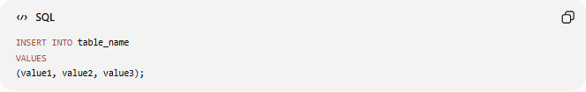
INSERT INTO table_name
VALUES
(value1, value2, value3);

Example
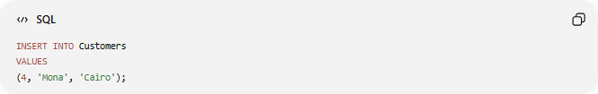
INSERT INTO Customers
VALUES
(4, 'Mona', 'Cairo');

⚠️ Values must be provided in the exact order of the table columns.

📚 Insert Multiple Rows
# Source: AI Source: Provided by: [Data Path: Persons Table -> ID Column: 1, Name_En Column: Motasem Essam] -> From: [ChatGPT] on [6/11/2026]
You can insert several rows at once.
Example
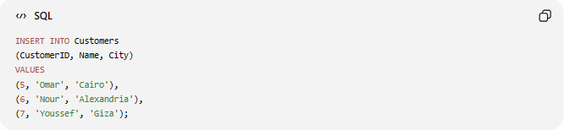
INSERT INTO Customers
(CustomerID, Name, City)
VALUES
(5, 'Omar', 'Cairo'),
(6, 'Nour', 'Alexandria'),
(7, 'Youssef', 'Giza');

Result
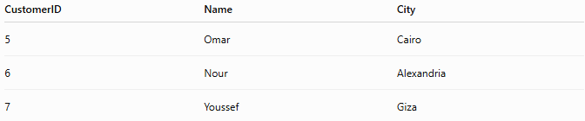
CustomerID | Name | City
5 | Omar | Cairo
6 | Nour | Alexandria
7 | Youssef | Giza

📚 Insert with NULL Values
# Source: AI Source: Provided by: [Data Path: Persons Table -> ID Column: 1, Name_En Column: Motasem Essam] -> From: [ChatGPT] on [6/11/2026]
If a column allows NULL:
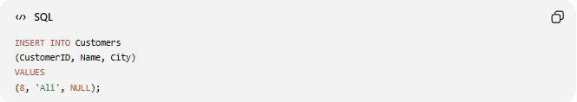
INSERT INTO Customers
(CustomerID, Name, City)
VALUES
(8, 'Ali', NULL);

Result
CustomerID | Name | City
8 | Ali | NULL

📚 Insert Using DEFAULT Values
# Source: AI Source: Provided by: [Data Path: Persons Table -> ID Column: 1, Name_En Column: Motasem Essam] -> From: [ChatGPT] on [6/11/2026]
Table
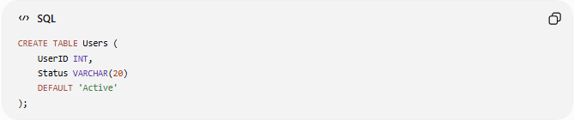
CREATE TABLE Users (
UserID INT,
Status VARCHAR(20)
DEFAULT 'Active'
);

Insert
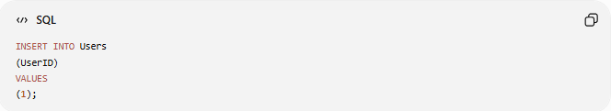
INSERT INTO Users
(UserID)
VALUES
(1);

Result
UserID | Status
1 | Active
The database automatically uses the default value.

📚 INSERT INTO SELECT
Copies data from another table.
Example
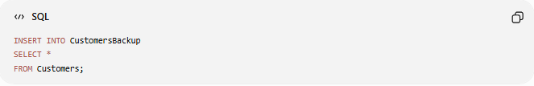
INSERT INTO CustomersBackup
SELECT *
FROM Customers;

Process
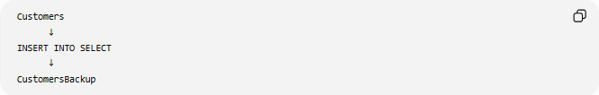
Customers
↓
INSERT INTO SELECT
↓
CustomersBackup
Data is copied from one table to another.

📊 Side-by-Side Comparison
# Source: AI Source: Provided by: [Data Path: Persons Table -> ID Column: 1, Name_En Column: Motasem Essam] -> From: [ChatGPT] on [6/11/2026]
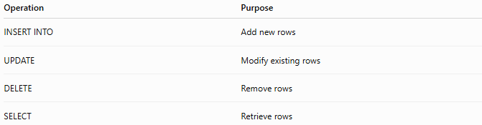
Operation | Purpose
INSERT INTO | Add new rows
UPDATE | Modify existing rows
DELETE | Remove rows
SELECT | Retrieve rows

🛠️ Complete Example
# Source: AI Source: Provided by: [Data Path: Persons Table -> ID Column: 1, Name_En Column: Motasem Essam] -> From: [ChatGPT] on [6/11/2026]
Create Table
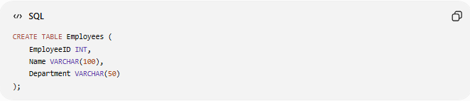
CREATE TABLE Employees (
EmployeeID INT,
Name VARCHAR(100),
Department VARCHAR(50)
);

Insert Data
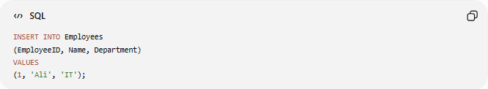
INSERT INTO Employees
(EmployeeID, Name, Department)
VALUES
(1, 'Ali', 'IT');

Result
EmployeeID | Name | Department
1 | Ali | IT

Real Example

prepared commands
# Source: ScreenShot Source: Provided by: [Persons Table -> ID Column: 1, Name_En Column: Motasem Essam] -> Tool: [Automation Table -> ID Column: 16, Name_En Column: Screen Capture] -> From [Operating System: Wampserver64 -> phpmyadmin] on [6/11/2026]
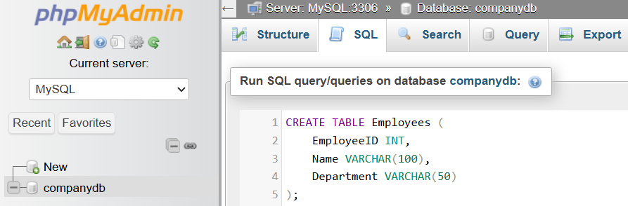
CREATE TABLE Employees (
EmployeeID INT,
Name VARCHAR(100),
Department VARCHAR(50)
);
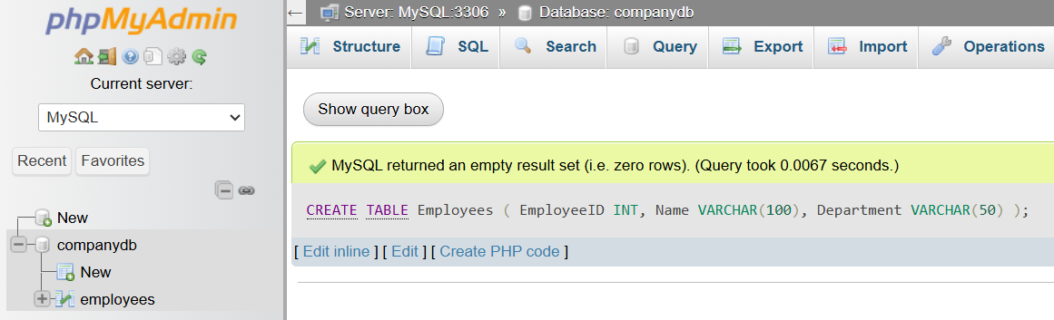
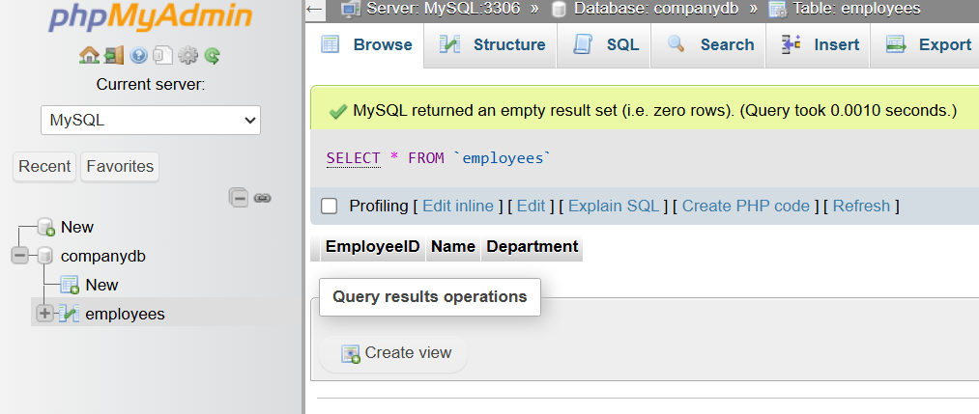

basic command
# Source: ScreenShot Source: Provided by: [Persons Table -> ID Column: 1, Name_En Column: Motasem Essam] -> Tool: [Automation Table -> ID Column: 16, Name_En Column: Screen Capture] -> From [Operating System: Wampserver64 -> phpmyadmin] on [6/11/2026]
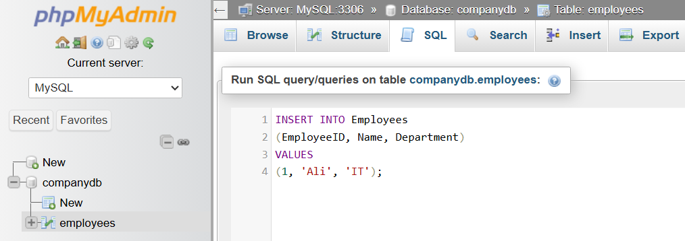
INSERT INTO Employees
(EmployeeID, Name, Department)
VALUES
(1, 'Ali', 'IT');
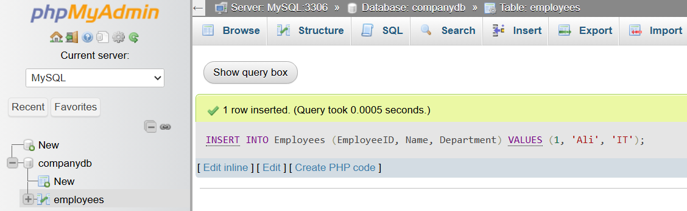
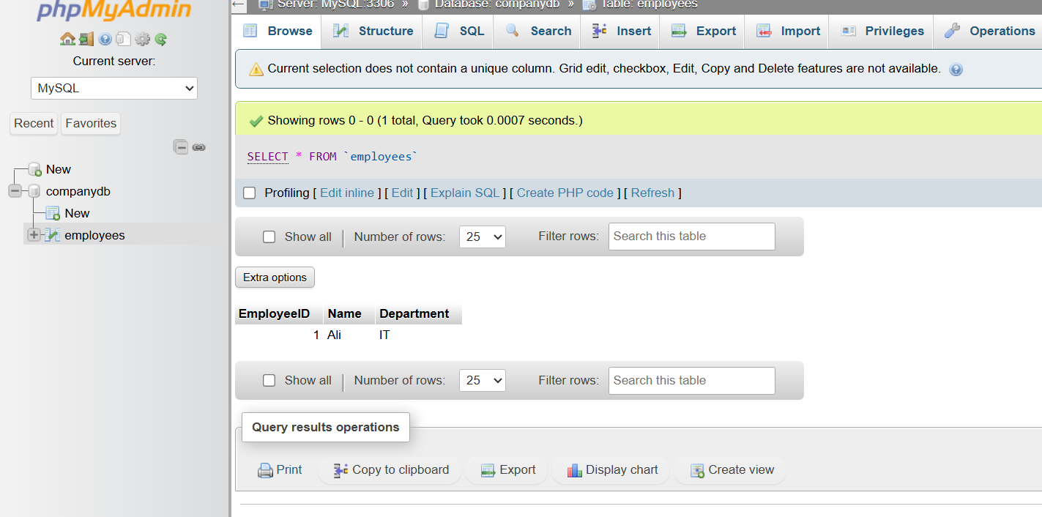

🌍 Real-World Example
# Source: AI Source: Provided by: [Data Path: Persons Table -> ID Column: 1, Name_En Column: Motasem Essam] -> From: [ChatGPT] on [6/11/2026]
Products Table
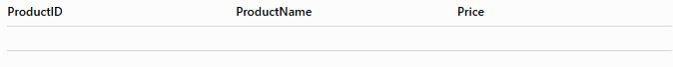
ProductID | ProductName | Price

Add a product:
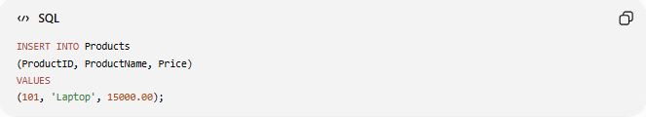
INSERT INTO Products
(ProductID, ProductName, Price)
VALUES
(101, 'Laptop', 15000.00);

Result
ProductID | ProductName | Price
101 | Laptop | 15000.00

⚠️ Common Errors
# Source: AI Source: Provided by: [Data Path: Persons Table -> ID Column: 1, Name_En Column: Motasem Essam] -> From: [ChatGPT] on [6/11/2026]
Wrong Number of Values
Incorrect:
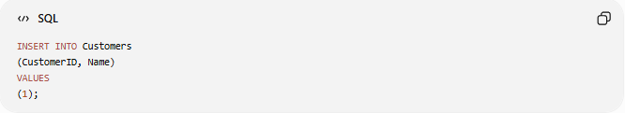
INSERT INTO Customers
(CustomerID, Name)
VALUES
(1);
Error because two columns require two values.

Data Type Mismatch
Incorrect:
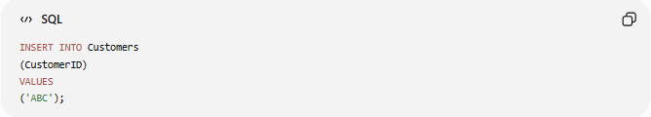
INSERT INTO Customers
(CustomerID)
VALUES
('ABC');
If CustomerID is an INT, this may fail.

Duplicate Primary Key
Incorrect:
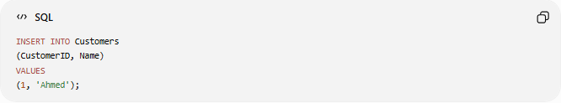
INSERT INTO Customers
(CustomerID, Name)
VALUES
(1, 'Ahmed');
If CustomerID = 1 already exists.

⚖️ Side-by-Side Comparison
# Source: AI Source: Provided by: [Data Path: Persons Table -> ID Column: 1, Name_En Column: Motasem Essam] -> From: [ChatGPT] on [6/11/2026]
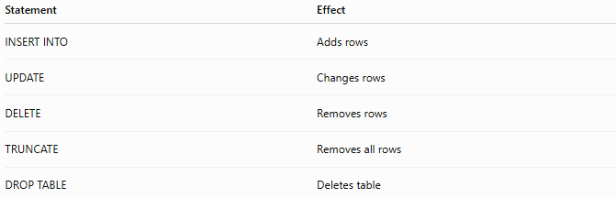
Statement | Effect
INSERT INTO | Adds rows
UPDATE | Changes rows
DELETE | Removes rows
TRUNCATE | Removes all rows
DROP TABLE | Deletes table

🔢 INSERT INTO Workflow
# Source: AI Source: Provided by: [Data Path: Persons Table -> ID Column: 1, Name_En Column: Motasem Essam] -> From: [ChatGPT] on [6/11/2026]
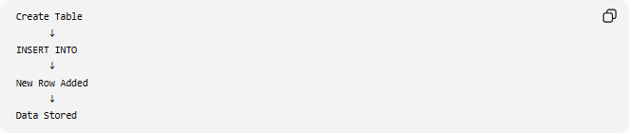
Create Table
↓
INSERT INTO
↓
New Row Added
↓
Data Stored

🧠 Simple Analogy
# Source: AI Source: Provided by: [Data Path: Persons Table -> ID Column: 1, Name_En Column: Motasem Essam] -> From: [ChatGPT] on [6/11/2026]
Think of a table as a spreadsheet.
Customers Spreadsheet
Using INSERT INTO is like adding a new row:

1 | Ali | Cairo
2 | Sara | Alexandria
3 | Ahmed | Giza ← New Row
The spreadsheet grows as new records are inserted.

🧭 Summary
# Source: AI Source: Provided by: [Data Path: Persons Table -> ID Column: 1, Name_En Column: Motasem Essam] -> From: [ChatGPT] on [6/11/2026]
SQL INSERT INTO is used to add new records to a database table. It can insert a single row, multiple rows, NULL values, default values, or data copied from another table using INSERT INTO SELECT. It is one of the core DML (Data Manipulation Language) commands used to populate and maintain database data.

